**CS385**

**Maynooth App – Project Documentation**

**Application Idea**

The main idea of the application was to create a tool for students to use in improving the quality of life of getting around the campus, finding important locations (such as labs, exam halls, shops, etc.) and organising assignments along with the student timetable. The app would utilise Google Maps to show users exactly where the destinations are located, along with route information and all the other benefits of using Google Maps. Additionally places like labs would include the timetable specific to that lab, while other locations would include general information such as opening times and website if applicable. The core idea of the application was to implement a simple design that lets the user easily and efficiently find places on the fly, using dropdown menus for organisation, as well as an aesthetically pleasing design, with a splash screen welcoming users into the app and colourfully animated backgrounds. The timetable and assignments section was also designed with a simple implementation in mind, letting users enter custom details which would be saved.

**Application Design**

The first step to actually designing the application was to create a MockFlow design of three of the main application screens – the Splash screen, the Navigation screen, and the Maps screen. These would consist of rough ideas of how the application should look, using the assets provided by the website. The Splash screen would feature the logo of the application, using some animation. The Navigation page utilised dropdown menus (known as Spinners within the Android library) to allow users to select which place they wanted to visit or find out about depending on the category it was in (i.e. “labs” or “shops”). Then the Maps screen would display that location on the map, using pins and descriptions, as well as opening and closing times and for certain places a timetable related to that place. There was also room for extra things such as website links and other important information.

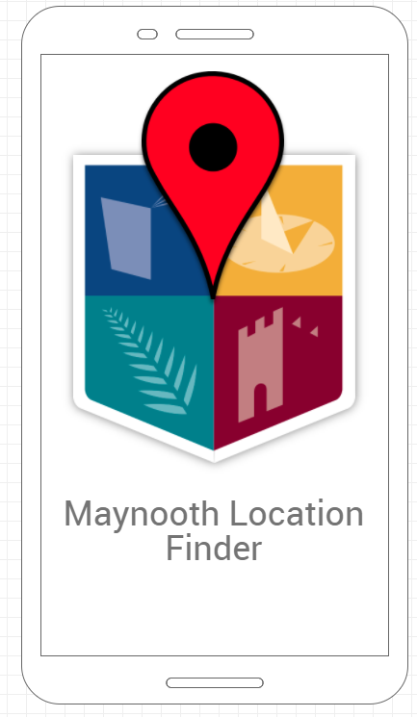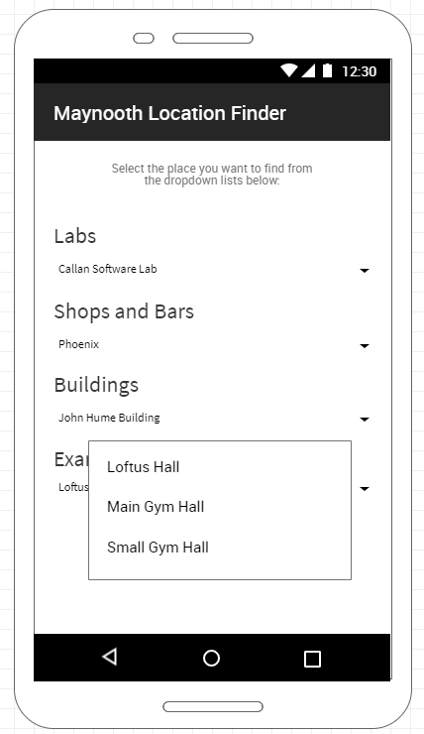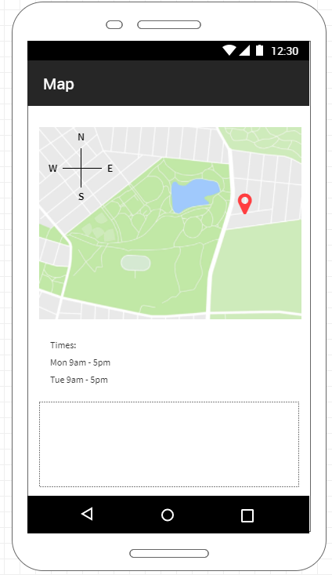

The goal of the UI design was to create a user interface that would be very simple and easy to use – ideal for finding the place you need to go on the fly or for quickly checking your upcoming assignments. With this in mind the overall design aimed for simplicity in the layout and organisation of elements. This can be seen in the use of dropdown menus to order and collect together the different type of venues, which helps users find the kind of place they need immediately without needing to scroll through a large unorganised list of every place to choose from. Another element of user friendly design was using help or documentation text to help guide the user through the program. This helps reduce confusion and makes the use of the application a smoother experience.

In terms of the application’s functionality, it is capable of displaying up to any number of locations and venues within the four different genres of places, which of course could be expanded to include a larger range or variety. The decision to use pre-determined places than just letting users input their own coordinates is to separate the app from just the basic functionality of Google Maps. With a selection of places to choose from, users need only select the place they need. In our version that we produced for this project, we only included a small selection for convenience sake, but in a full scale version potentially all relevant campus buildings would be covered. Upon selecting a location, the user is immediately brought to the map screen, with their selected location pinned on the Google Map interface along with the name of the location if the pin is tapped.

Another main functionality of the app is the ability to access a timetable screen that the user can edit to fully input their weekly timetable. This timetable saves itself once edited, and of course can be changed if needed. Also available on this section of the app is the modules page, which again lets a user input the subjects they have with their module codes to help them keep track of which modules they currently have as well as the class room or location of that module. This overall functionality is aimed at the app’s goal of helping a student stayed organised.

**Implementation**

The application made use of many typical Android components. It features several activities, such as a Splash activity, Main (Navigation) Activity, the Timetable and Modules activities, and the Maps activity. These activities use Intents in order to move between them, and in the case of the Navigation page, these Intents make use of putExtra() in order to deliver information across activities. This is used to send information on the longitude, latitude, and name of the venue to the Maps activity, which uses the Google Maps API to bring the focus to those coordinates on the map and pins it.

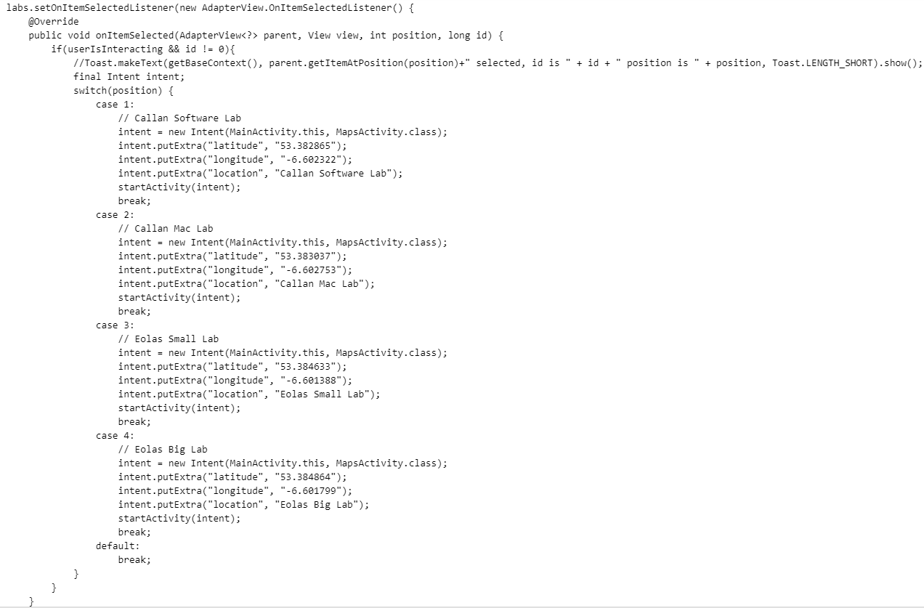

The above is an example of this Intent code for the labs, which uses an OnItemSelectedListener to check for which option in a Spinner is selected, and then startActivity() starts the Intent to the Maps screen with the relevant coordinate information based on which option was selected. Within the Google Maps API is the onMapReady() function, which executes when the activity is loaded. The Intent is received from the Navigation activity and parses the coordinates into doubles (from the String data the Intent sends), then creates a new LatLng() object with those coordinates. Additionally a marker is added with the name of the venue, as well as zooming the camera close to that location. This can be seen in the code snippet below.

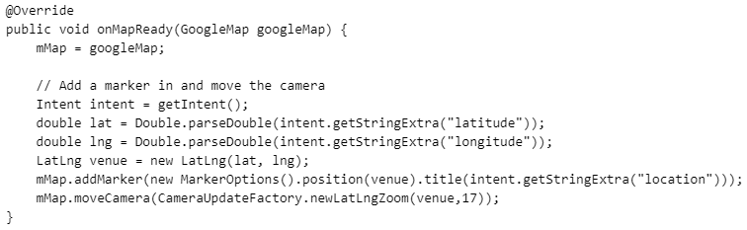

To make those Spinners (dropdown menus) work in the first place, it was required to set up a series of arrays to hold the information about each type of venue. Since we weren’t going to be doing this full scale, we used a small selection of a few different types of places. Naturally this list could be expanded easily.

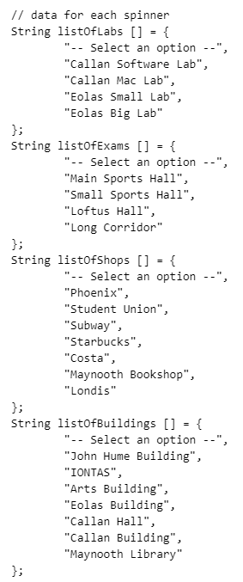

Each Spinner had to have an ArrayAdapter attached to them in order for it to read the data out of each array. These ArrayAdapters (which were of type <String>) were set a style as well as an array to correspond to. For extra readability, getDropDownView() was used to make every other option in a dropdown list have a grey background colour. Afterwards the Adapters get set to the Spinner objects.

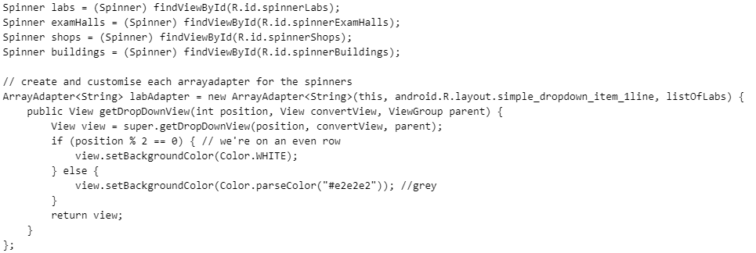

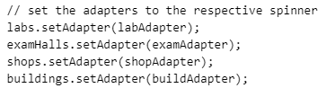

**Team Organisation**

When we started the project, we created a group on the Messenger app in order to communicate and collaborate more efficiently. We discussed a couple ideas, voting using polls to pick for sure and eventually settling on the one we ended up doing. Having decided what we would do, we begun brainstorming ideas and features for it.

* Niall worked mostly on the app’s design, from creating the initial Android Studio activities and the MockFlow diagrams, and creating the Navigation page and the Maps page.
* Ethan created the animated Splash screen as well as implementing the music player for the Splash screen, and the animated background throughout the app.
* Olumide developed the Timetable and Module Details pages, which were integrated into the main application.
* Orán helped with developing the concept of the application, as well as coming up with additional features.

Meetings were usually held on Friday mornings to discuss progress on the project. Additional meetings were organised to prepare for the presentation. Once again Messenger as a means of communication was vital to this.